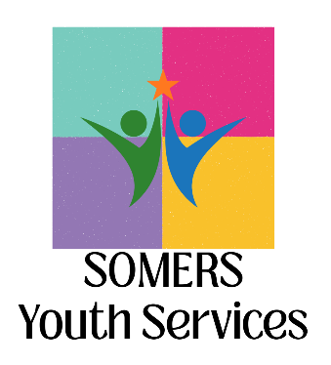
Somers Youth Service Bureau Advisory Board
Agenda
March 25 – 4:30pm to 5:30pm
Kibbe Fuller Community Room

- Call to Order

- Welcome and Introductions

- Review and Approval of Minutes of November 12

- New Business / Updates from the Field
  - Schools
  - Law Enforcement
  - Youth
  - Parents/Families
  - Community

- Program Updates and Next Steps
- Youth Service Bureau
  - Holiday
  - Teen Center – Community Give Back Opportunities
  - Safe Sitter
  - Truancy
  - Youth Diversion Team
  - Prevention Highlights

- Other/Announcements
  - Community Information Hub

- Adjourn
Future Meetings
May 20, 2026*
September 9, 2026
November 18, 2026*

*note date changes due to scheduling conflicts

